Best Practice Guidelines for working with External Mental Health Services including Schools’ Mental Health Teams v.2

The social, emotional, and mental health needs of Children and young people can most often be managed within an embedded Whole School Approach that promotes wellbeing within its ethos. There is an understanding that the emotional wellbeing and mental health of all children and young people will fluctuate for short periods of time based on events, changes, and challenges in everyday life. There is also a need to think more broadly and to assess what is going on for the children and young people in the physical environment, home/social environments or within the context of the classroom, for example, the cognitive demands. It is also vital to consider the impact of transitions within the school/setting.
When thinking specifically about mental health and wellbeing it is important to remember that these needs sit along a continuum.
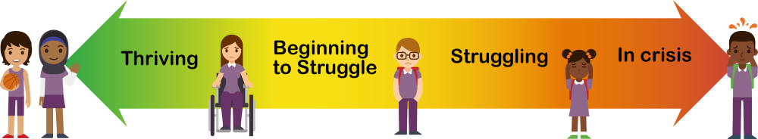

Schools’ Mental Health Teams work to support pupils across these different levels of need. All pupils will benefit from green level support with some needing early intervention at yellow level and a few needing orange or red level intervention. Your school mental health lead should be aware of support available both internally and externally. Further information about specific services can be found on Liverpool’s Mental Health Lead Hub. These interventions should be mapped into your whole school approach offer and shared with your staff team.
To get the most out of these services in schools, the Liverpool WSA partnership recommends the following best practices:

- School Mental Health Termly Meetings

School hold termly meetings with practitioners from external services and key members of staff from the school to look at current needs and decided the most appropriate support available. The school Mental Health Lead can make use of the following recording sheets to document the session and record key actions.

- Designated school contact

Schools have a designated Mental Health Lead who is the main point of contact with services. In larger schools this role may be shared between staff who will work collaboratively. If this member of staff changes, contacts details will be communicated with the mental health practitioners and who will update their shared school contact list. Practitioners must also know and be able to easily contact school safeguarding lead/s should any concerns arise whilst in school.

- Consistent approach

Where schools have a consistent approach to working with services, appointments are generally not missed, and the best use is made of practitioner time. It is helpful for teaching staff to be aware that a young person is scheduled to have an appointment on that day and for someone to be available to fetch them if needed. Check-in at the start and debrief at the end of the day with the service practitioner ensures that the MHL is aware of progress made with the young person (without breaking confidentiality). Half-termly review meetings are also beneficial.

- Appropriate space

Rooms allocated must be suitable for the interventions taking place and be free from interruptions. Young people are often concerned if their peers can see them in sessions or may struggle to access interventions effectively if the space isn’t comfortable and welcoming. As practitioners often need to upload clinical notes electronically during sessions, good WIFI connections are important.

- Follow-up

Young people may find it difficult to adjust straight back into lessons following a session. Having a safe transition space such as a school wellbeing haven can be useful. Making staff aware that pupils are joining their lesson following a session may also prepare them to provide a supportive environment and be aware of possible dysregulation. Consultation and supervision is available through the Schools’ Mental Health Teams to support school staff dealing with particularly complex cases.

- Communication

Effective communication between schools and services makes a huge difference to the support provided. Mental Health Leads should discuss with their practitioner the most efficient way to do this. Communication about the service being offered with parents/carers is also very important. Consent must be gained before any clinical intervention along with clear information about what the young people is being referred for and the support they will be receiving.

