Book Awards 2025

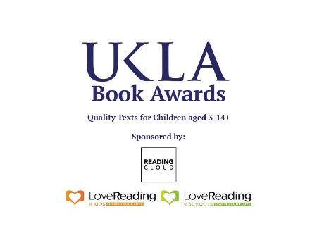

Application to be a Teacher Judge

Teacher Judges undertake to:
- read all of the submitted books and share them with their children/students;
- attend book groups (these might be online or in person, according to the wishes of the group) to discuss the submitted books;
- keep in touch with the Book Group leader;
- Attend the Launch Meeting in September 2024 (probably online), the online Book Awards CPD meeting in January 2025 and the in-person shortlisting meeting in March 2025 (this will be a half day meetings at Liverpool John Moores University). All of these meetings will take place on a Saturday, to minimise any staffing issues in your school.

School name and address
Teacher name
Email address

Category  (Please circle your chosen category) | 3-6+ 7-10+ 11-14+ Information Books 3-14+
Headteacher name
Email address

Signed headteacher
Date

School / Individual
UKLA membership number

Not a member? Join on-line www.ukla.org

Please complete this form (one form per Teacher Judge) with details and signed consent from your headteacher and email to:
Chris Lockwood, Chair UKLA Book Awards: LockwoodC@ukla.org

