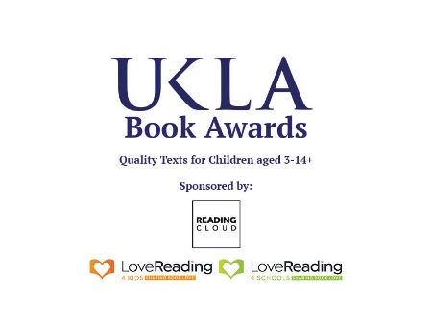
UKLA BOOK AWARDS 2025

Information for teacher judges

The UKLA Book Awards is the only children’s book award which is judged entirely by teachers. For the 2025 Book Awards, the UKLA is looking for teacher judges who teach in schools in within travelling distance of Liverpool. Would you like to take part in this prestigious award?

First of all, all teachers must be members of the UKLA. The membership – school, institution or individual – can be organised on the UKLA website:
www.ukla.org
In practical terms, the value of the books received by a teacher judge is greater than the cost of membership. But there are other advantages to membership of UKLA, especially the partnership with other professionals in schools, such as the OU / UKLA Reading for Pleasure groups, universities and libraries who are engaged and interested in linking the best of current research to its practical application in the classroom. UKLA members receive regular magazines and newsletters, have access to articles on-line and benefit from reductions to national and international conferences organised by the UKLA and our partners. In addition, there are many awards and grants to apply for - do explore the website.

The Book Awards are organised into four categories; three, for fiction and poetry, are organised in age groups, 3-6+, 7-10+ and 11-14+. The fourth category, Information Books 3-14+, will be judged by teachers across all phases of education.

We are looking for teachers who are passionate about Reading for Pleasure and who are knowledgeable about the impact of reading on schools and their pupils. We aim to recruit three groups of Teacher Judges for each category. Each group will be led by a Group Leader with approximately six teachers in each group, and if we can, a balance of experienced and early career teachers; the most important criterion is that our teacher judges are passionate about Reading for Pleasure. If they are not already knowledgeable about high quality, recently published children’s literature, the process of judging will certainly spark that enthusiasm and passion. At the end of the process we hope that our judges will be teachers who read and readers who teach.

The longlisted books are posted out - free! - to Group Leaders and Teacher Judges from the beginning of September 2024. We have a spreadsheet on Google docs which we ask you to update as each book arrives from the publishers, so that the UKLA team can monitor that the books have safely reached you. At the end of the process, the books belong to the teacher judges and their schools and the group leaders.

We ask teacher judges to commit to reading the 20 longlisted books they receive and sharing them with their class and colleagues. The schools which are most successful manage to turn the experience into a whole school event. In order to keep in touch, we organise three Saturday events during the year. The first, in September 2024, will be a launch event, so that the UKLA team can introduce themselves and then reveal the longlisted books. Book group leaders will have the opportunity to meet the teacher judges in their groups in person so that each group can then organise dates and times which suit them for the book groups to meet; most groups meet two or three times in the autumn and spring terms, mostly using Zoom or Teams, and keep in touch online.

We meet again online as a whole group in January, again on a Saturday morning, to catch up on progress and to hear what other book groups and individual schools are up to. We use this event to introduce some CPD – this year we had two keynote speakers. Dr. Melanie Ramdarshan Bold, speaking on the importance of representation for the authors and illustrators of children’s books, was the winner of the UKLA Diversity and Inclusion award in 2023. Jeffrey Boakye, winner of the Information Books category in the UKLA Book Awards 2023, entertained us with his own very personal take on the importance of diversity and inclusion in children’s publishing.

The last meeting with the UKLA team is in March, again on a Saturday morning, where we meet in person in our category groups and battle out the shortlists for each age group – six titles for each category. This is an in-person meeting – it is a joy to meet all of our teacher judges and hear their enthusiasms for the books.

After that, each book group nominates one teacher judge who goes forward to the final panel. The final panel receive all 24 of the shortlisted books, the six titles from each of the age categories for fiction and poetry, and six titles from the Information books, which they read and share, ready for the selection of the winners at a meeting in June. The winners are announced at the Book Awards ceremony at the International Conference in Liverpool in July 2025.

For those teacher judges who are not part of the final panel, and missing the fun of choosing the winning book, we invite them to join one of the shadowing groups. These are open, as soon as the shortlists are announced, to any UKLA teacher. Voting is organised online in June, and the winners of the Shadowing awards announced at the International Conference in July.

All of the teacher judges and group leaders are invited to attend the Awards Ceremony on the Friday evening of the conference, and then have an opportunity to get their books signed by the shortlisted authors and illustrators. This event will take place at Liverpool John Moores University on 25th June 2025.

Please contact:
Chris Lockwood
Chair UKLA Book Awards
LockwoodC@ukla.org

